# **Name: Abdurrahman Qureshi**

# **Roll No: 210451**

Practical No: 10

**1) Write a program to create persistent cookie.**

**CODE:**

<!DOCTYPE *html*>

<html>

<head>

  <title>Simplified Persistent Cookie Example</title>

</head>

<body>

  <h1>Simplified Persistent Cookie Example</h1><button *onclick*="setPersistentCookie()">Set Persistent Cookie</button>

  <script>

    function setPersistentCookie{

      const cookieName = "myPersistentCookie";

      const cookieValue = "This is a persistent cookie value";

      const expirationDate = new Date();

      expirationDate.setDate(expirationDate.getDate() + 30);

      document.cookie = `${cookieName}=${cookieValue}; expires=${expirationDate.toUTCString()}; path=/`;

      alert("Persistent cookie has been set.");}

  </script>

</body></html>

**OUTPUT:**

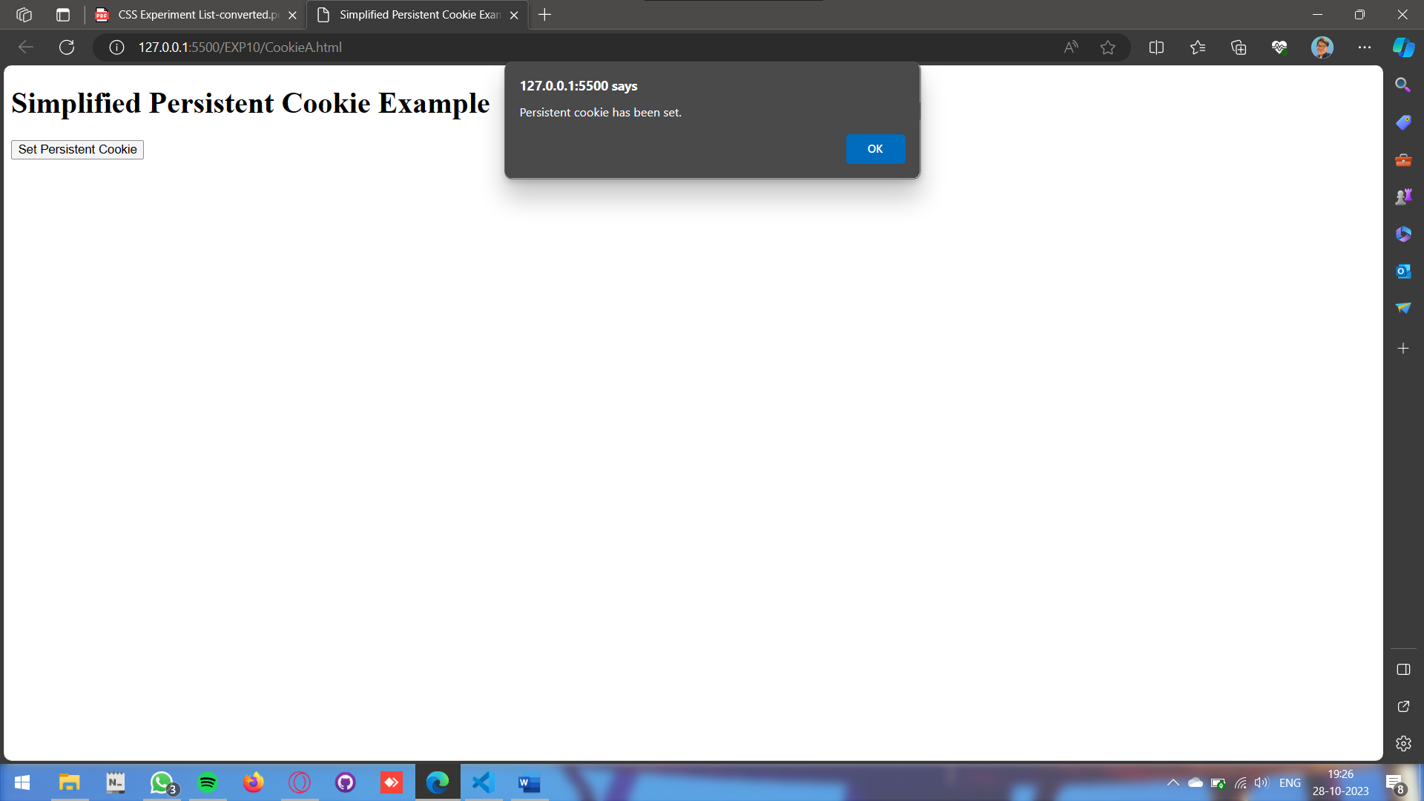

**2) Write a program to create session cookie.**

**CODE:**

**<!DOCTYPE *html*>**

**<html>**

**<head>**

**<title>Session Cookie Example</title>**

**</head>**

**<body>**

**<h1>Session Cookie Example</h1>**

**<button *onclick*="setSessionCookie()">Set Session Cookie</button>**

**<script>**

**function setSessionCookie() {**

**const cookieName = "mySessionCookie";**

**const cookieValue = "This is a session cookie value";**

**document.cookie = `${cookieName}=${cookieValue}; path=/`;**

**alert("Session cookie has been set. It will KILLED WHEN U KILL THE BROWSER jk.");**

**}**

**</script>**

**</body>**

**</html>**

**OUTPUT:**

